How to set up new client portal
Setting up Clients in Portal:
Step One: Gather Client Name & Email
Step Two: Once logged into portal, click on Admin, users, and then in the middle column at the bottom click add.
Step Three: Click Single User- auto notification.
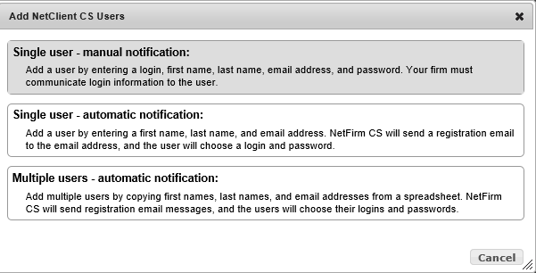
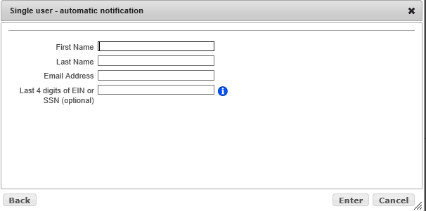
Client will receive an email notification to register their client portal. They
choose their username and password.

Step Four: Click Enter

Step Five: Click on Client that was added and on the left you will see a series of boxes. Click on the Enable box by file exchange, this will bring up boxes. The boxes that will be used for all portal clients are Tax Documents to RHW & Actionable Items From RHW, click those boxes in the full column.
Step Six: Click enter. These options allow the client to upload documents to us as well as RHW to upload Actionable Items to the client.
Step 7: Email new client that portal as been set up. Include the instructions pamphlets
-Register Client portal directions
-New Thomson Reuters Authenticator Set up
-Uploading to RHW Client portal

Ex: Good Morning Jessica
Thank you for considering RHW CPA’s for 2022 tax returns.
Attached are the instructions for setting up the RHW client portal and how to upload documents to the portal.
I have also included the instructions to set up the Multi factor auth.
If you have any questions please let me know
Thank you

Note: You can also create a client portal from Practice in the client’s set-up file. However, you will still need to login to Admin side of portal to enable file exchange folders.

How to upload files to the portal from client side of portal:

Step One: Once signed into the portal click on Admin, then click users on the left below Admin. Find the client you would like to Enable File Exchange and then Click on “Enable” on the right of the screen next to client’s information.

Step Two: Click on Client that was added and on the left you will see a series of boxes. Click on the Enable box by file exchange, this will bring up boxes. The boxes that will be used for all portal clients are Tax Documents to RHW & Actionable Items From RHW, click those boxes in the full column.

How to send documents to Portal from File Cabinet (Document Presentation):
Step One: Click Open Client Drawer. Make sure drawer has icon of 2 computers at
bottom of client drawer.
If no icon, right click client drawer.
Enter “Drawer Email”
Check Box for “Designate this drawer as a contributor to NetClient CS.

Step Two: Click on the image or the document you want. Drag & Copy the image or
document to the “NetClient CS” 2 computer icon at the bottom of the client drawer.

Step Three: Once all images or documents have been copied into “NetClient CS”, Click on
Red Plug at the top of File Cabinet.

Step Four: When box appears, under “Purpose of this Call”, “NetClient CS:”, Click “Select Drawers”.
Find the Client or Clients in left hand column, Highlight, Click “Select”. Client should have moved over to right column

Step Five: Click “Ok”
Make sure that the other Boxes (Retrieve available updates, Retrieve Licenses) are Unchecked

Step Six: Click “Call Now”

Note: Whatever you drag & copy in File Cabinet NetClient CS, will be transmitted to the client
portal when red plug is pushed.

If you add an image or document to the “NetClient CS” computer Icon,
Highlight the image or document under “NetClient CS” Computer Icon.
Right Click
Click “Document Properties”
Uncheck the box next to “NetClient CS” Computer Icon
Click “Close”

How to connect Client FC drawer to a Client’s Portal:

Step One: Once signed into the portal click on Admin, then click users on the left below Admin. Find the client you would like to Enable “Document Presentation” and then click “Enable” on the right of the screen next to “Document Presentation”.

Step Two: Search for Client in the box that appears on your screen. Only Check the client drawer you want to connect to that particular client portal.

Step Three: Click “Enter”

Note: You can connect any client drawer or multiple client drawers to 1 client portal. You can also disconnect a client drawer from a portal at any time.
File Cabinet:
Step one: Search for client, either by last name or Client ID number
Step two: Right click to bring up a drop down box,
Select : “Drawer Properties”
Add client Email that was used to set up the portal
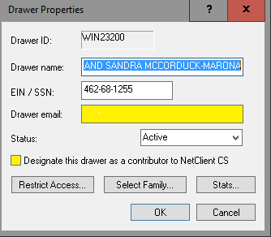
Step Three: Click “OK”
This will add {NetClient CS} to the bottom of the file list for the client
Step Four : From the top bar chose the RED Plug
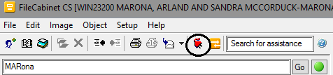
Step Five: UNCHECK “Retrieve available updates”
Check “Transmit to NetClient CS”
Click on “Select Drawers”
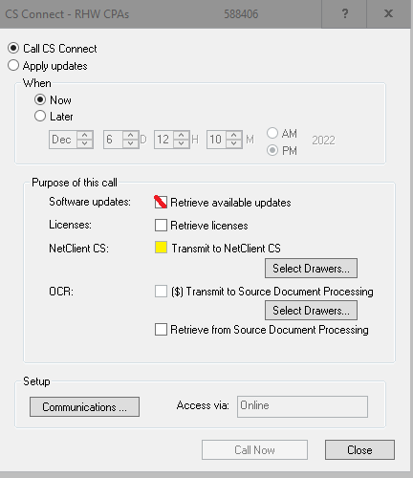
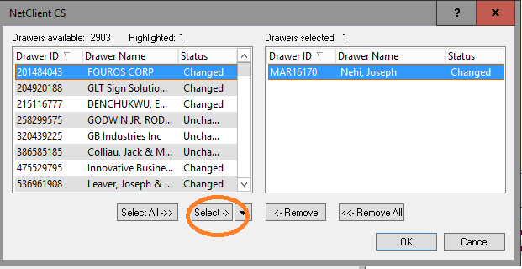
Step Six: Click “Select” this will move the last searched file to the right column,
Reminder to remove the un-needed files from the right column.
*Note: you can add multiple files to send to the portal in batches
Click “OK”
Step Seven: Click “ Call Now”
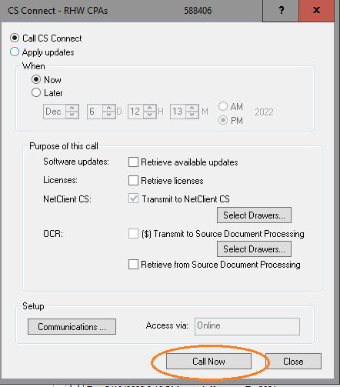

Changing Client Login information and Password:
Step One: In portal click Administration.
Step Two: Click on Users in the NetClient CS section.
Step Three: In the user’s column, select the appropriate NetClient CS user.
Step Four: In the identification section, modify the First Name, Last Name and Email Address fields as necessary.
Step Five: Client can reset own password. However, if you need to change the NetClient CS user’s password, enter the new password in the Change Password field and enter it again in the Confirm Password field.

Multi Factor Auth set up
To Assist Clients in setting up the new Multi Factor auth
New Thomson Reuters Authenticator set
For setting up the new Thomson Reuters Auth App to your Netclient portal
You will login like normal.
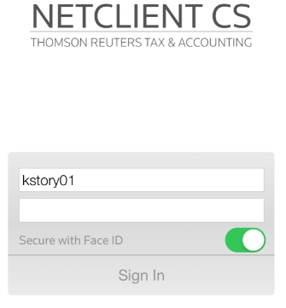
If you cannot remember your password, select “Forgot Password” and the system will generate an email with a temporary password for you.
Once you have input your login and password, you will click on
“I am not a robot “
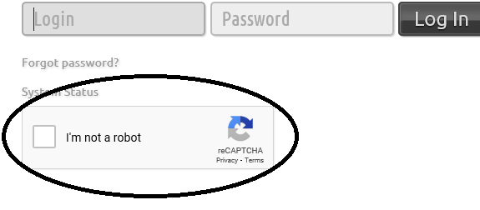
The system may ask you to select all images:
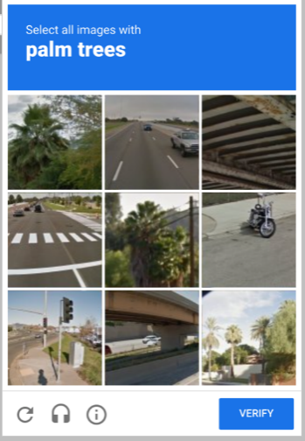
Once you have selected the requested images and click the “VERIFY” button.
The system will prompt you to set up the Multi Factor Authenticator
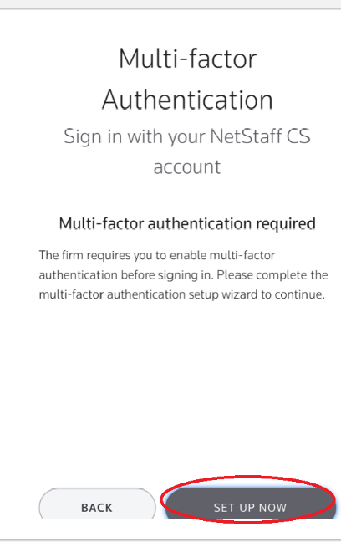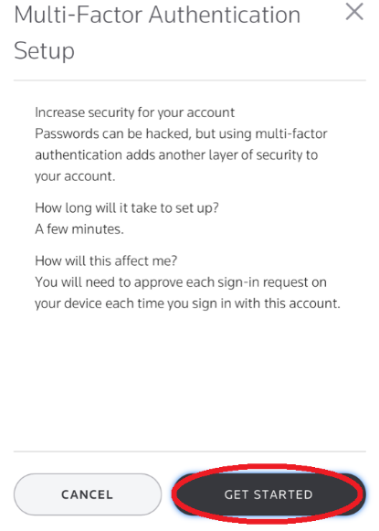
You will click on “SET UP NOW” Then “GET STARTED”
You now need to download the app from either the App Store (iSO) or your Google Play Store (Android).
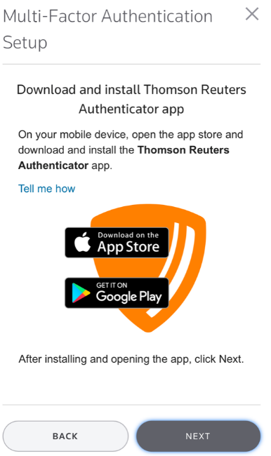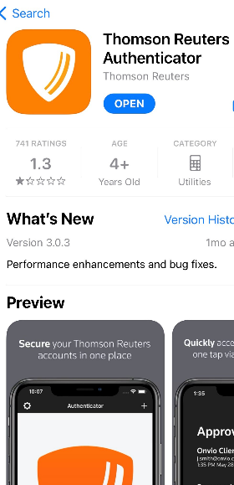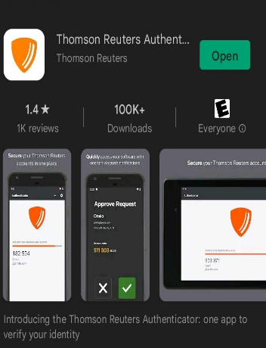

Once you have downloaded the app, you will open the app:
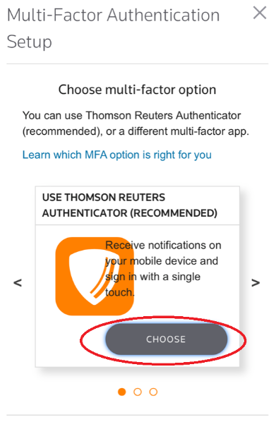Select “CHOOSE”

A QR Code will show up on your DESK TOP SCREEN
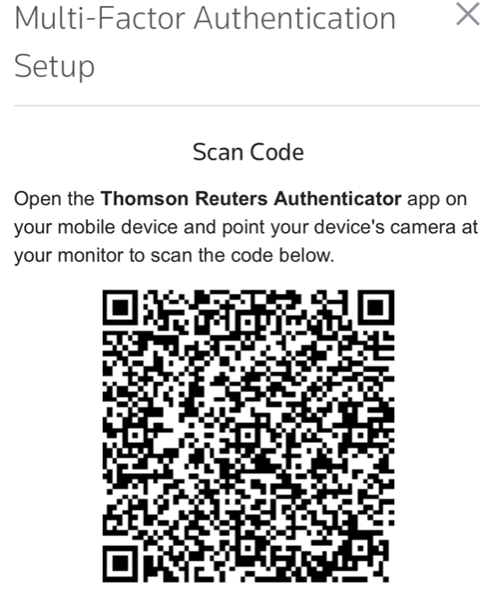
You will then scan this with the app by going in the app and selecting the “settings”  on the main screen, this will take you settings page.

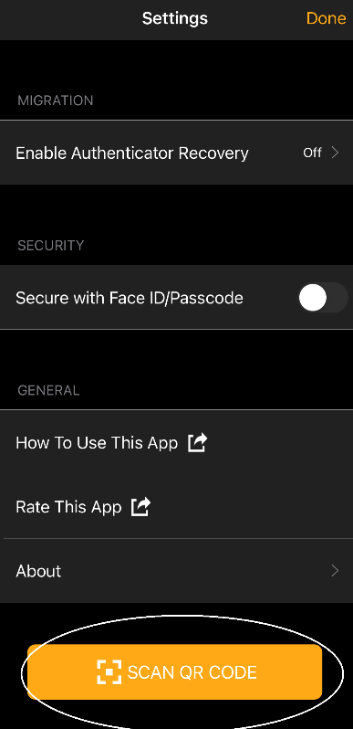
Select “SCAN QR CODE”
This will link you app to your account,
